Task 1 問題パターン
タイプ | 出題率 | 概要
Graph  (グラフ) | 約85% | Line Graph (線グラフ)、Bar Graph[chart](棒グラフ)、Pie Chart (円グラフ)、Table (表)の4種と、これらが組み合わさって出題される混合タイプの合計5種類で、数値（の変化）を比較-分析し描写します。
Diagram  (図表) | 約15% | 町・都市の変化や部屋・建物のレイアウト変化を描写するMap Diagram（地図）と、製造・加工の工程や動植物の成長過程を描写するProcess Diagram (工程)の2種類があります。

採点項目
Task Achievement (タスクの達成度): 正確な数値と変化の分析、描写。
Coherence and Cohesion (一貫性と意味上のまとまり): エッセイ全体の一貫性。
Lexical Resource (語彙の運用力): 語彙の正確性と幅広い運用力。
Grammatical Range and Accuracy (文法知識): 文法の幅広い運用力と正確性。

important / significant / essential / crucial / indispensable / A ☞ A’ ☞ A’’ ☞ A’’’
スコアアップ最重要ポイント
- 全体の概要が書けているか
☞ これがないとTask achievement (タスク達成度)は5.0止まりとなります。

- パラグラフ構成は適切か
☞ 情報ごとにパラグラフが整理されており、まとまりがあるかが重要です。

- 数値の描写に誤りがないか（グラフ問題の場合）
☞ 数値の書き間違いは大きな減点につながるので、慎重に描写しましょう。

- 比較できているか（グラフの場合）
☞ 単体で描写するのではなく、関連のある個所を比較することが重要です。

- 各問題パターンに適した表現を運用できているか
☞ グラフ問題、図表問題、それぞれに特有の表現を使うことが大切です。
最重要: Integrated Taskの構成
- Introduction ☞
問題文のパラフレーズ + Overview
(全体の30%: 40～60 words)

情報ごとに分類し、細かな数値や段階を詳細に述べます。Bodyは３つで構成しても構いません。
(全体の70%: 110～150 words)

- Body 1 ☞
- Body 2

6.5 – 7.0点突破のための必勝攻略法は:

必勝攻略法① 24分間を目安に仕上げること！

必勝攻略法② Overview (全体の概要)を重視せよ！
*overviewなくして採点基準のひとつであるTask Achievement (タスク達成度)の項目で6.0以上とることは不可能です。

- 細かな数値を入れないこと
☞ ただし年代、月を入れることは可。詳細な数値の描写は、ボディパラグラフで行います。
- Overall(全体としては)で書き始めること
☞ こうすることで、読み手に「概要を示しますよ」という目印になります。

必勝攻略法③ Overviewはイントロで書くこと！
イントロの書き方
- 1文目: 問題のパラフレーズ（言い換え）
- ２文目: Overview (概要)

- Task2と異なり、Conclusion（要約）は不要。

必勝攻略法④ 必ず比較・対照をする！
Task 1のTask Achievement (タスクの達成度)を高めるための鍵として「比較・対照の精度を高めること」が挙げられ（一部のDiagramを除く）、問題の指示文には毎回make comparisons where relevant. (関連性のある箇所を比較すること)という文言があります。ですので、比較・対照することを毎回意識し、分析することを心がけましょう。

必勝攻略法⑤ 意見や考察を書かない！
Task 1では、与えられたデータや情報の「客観的な分析とその正確な描写」が求められるため、主観的な見解は不要です。また、表や図に示されていない情報を推測した情報も書いてはいけません。

必勝攻略法⑥ 数字表記の３のルールをマスター！
以下で紹介する一定の数字表記のルールと記号をマスターしておきましょう。

10以下の数字はスペルアウトし、それ以上はアラビア数字で書く。
ルール1

例) There are [×6] six people in my family.

ただし次のようにケタが大きければ、アラビア数字を用います。
〇 around 6 million people

ルール2
文頭の数字はスペルアウトする。

例) [×600] Six hundred students will attend the meeting.

ただし数字の前に単語があれば、アラビア数字を用います。
Around 600 students

ルール3
「%」の前は、通常アラビア数字で書く。

例) × eight % of students → 〇 ８% of students

次の語は記号で書く。
その他

dollar →＄ pound →￡ euro → € ton → t kilogram → kg
IELTS Writing Task 1 (Pie Chart = 円グラフ)
You should spend about 20 minutes on this task.

The charts below show the average percentages in typical meals of three types of nutrients, all of which may be unhealthy if eaten too much.

Summarise the information by selecting and reporting the main features, and make comparisons where relevant. dairy

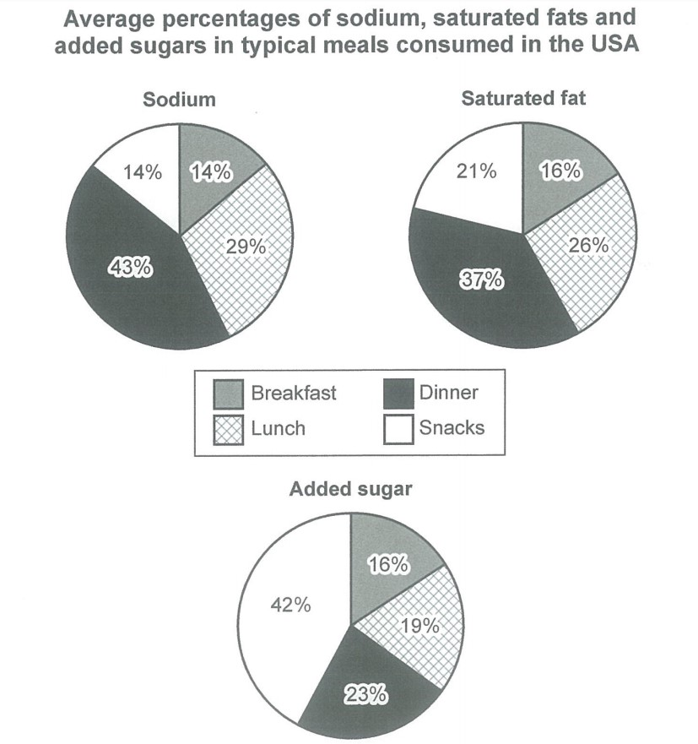

Introductionの書き方

- The charts below show the average percentages in typical meals of three types of nutrients, all of which may be unhealthy if eaten too much.
☟
Paraphrase = 言い換える

例) The three pie charts illustrate (show / provide information on / compare ～ in terms of….) the average proportions of three types of nutrients such as sodium, saturated fat and added sugar in typical American meals, the over-consumption of which may have a detrimental (= negative) effect on health.

- Overall (概要)

例) Overall (All in all), the majority of sodium and fat were consumed at dinner, while most sugar was eaten in snacks. Lunch also tended to be salty and have plenty of fat while breakfast had the lowest percentages for all three nutrients.

「構成」を描写する表現をマスターしましょう！

主語 + account for [comprise / constitute / represent = ～％を占めている] +次の①～③のいずれか

- 数値 (～%)
- the majority (51%以上) of / a half of / a quarter of / two-thirds ofなど
- a large [high] of、またはthe highest [largest] proportion [percentage / share] of
* the vast majority of のようにmajorityを強調する場合は71％以上を示す

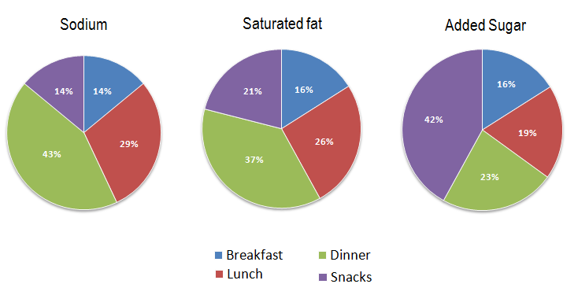

-Dinner accounts for 43% of the total proportions of sodium.
-Dinner constitutes roughly a third of the total proportions of sodium.
-Dinner comprises the largest share of the total proportions of sodium.
-Lunch accounts for slightly over one quarter of the total proportions of saturated fat. (4分の１よりやや上)
-Dinner and lunch combined comprises the majority of the total proportions of sodium.（大部分）
-Breakfast and lunch represent similar proportions of added sugar, 16% and 19% respectively. (近似値)

Sample Answer (based on nutrients)

The graph shows how much sodium, saturated fat and added sugars were consumed in the average meal in the United States. Looking from an overall perspective, it is readily apparent that the majority of sodium and fat were consumed at dinner, while most sugar was eaten in snacks. Lunch also tend to be salty and have a lot of fat while breakfast have the lowest percentages for all three nutrients.

Dinner and lunch have roughly similar, large proportions for both sodium (43% for dinner and 29% for lunch) and saturated fat (37% for dinner and 26% for lunch). The amount of sugar in an average meal for dinner and lunch is much lower at 23% and 19%, respectively.

Turning to breakfast and snacks, which also have comparable percentages, they are both made up of 14% sodium. For saturated fats, snacks contains 21% and breakfast is slightly lower at 16%. In terms of sugar, there is the greatest disparity with 42% of snacks (which is) being sugary and just 18% of breakfast (which is) being made up of sugar.
(174 words)

Vocabulary
- consumed: eaten
- average meal: the amount that people normally eat
- readily apparent: very clear
- majority: most of
- tended to: usually did
- nutrients: the compounds that make up foods
- roughly similar: not that different
- respectively: in turn/for each category
- turning to: looking at the next area
- comparable: similar
- made up of: composed/consisting of
- slightly lower: a little bit less
- the greatest disparity: the biggest difference
- sugary: full of sugar/sweet

Sample Answer 2:

The pie charts illustrate the ratio of sodium, saturated fats and added sugar in four average daily meals consumed by Americans. The percentages of these three nutrients in breakfast, lunch, dinner and snacks that American citizens generally consume are given and they are detrimental for health if consumed plenty in quantity.

Overall, dinners and lunches that the USA residents consume are sodium and saturated fats rich while their snacks have a high portion of added sugar.

In details, USA citizens' sodium, sugar and saturated fats intake during the breakfast is comparatively lower, around 14-16% each time. Intake of these nutrients is considerably higher in food items they eat during lunch and dinner. The lunch they eat comprises of 29% sodium, 26% saturated fats and nearly 20% sugar. They consume much higher percentages of these nutrients, which are harmful to health when eaten too much, while they have their dinner. Their intake of sodium, saturated fats and sugar during dinner are 43%, 37% and 23% respectively. Finally, the snacks they enjoy contain high sugar and fats, 42% and 21%, respectively, and the sugar intake in snacks is higher than that of dinner and lunch.

