Cambridge IELTS 12 TEST 6
Academic Writing Task 1
Diagram Writing (Map)

In IELTS Academic Writing Task 1, different kinds of map questions can be given. Yet, the followings are most common. So, we can divide maps into three major categories.

- Describing one map in the current time. <quite rare>
- Describing two maps – one in the current time and the other in the future. <the most common>
- Describing two maps – one in the past and the other in the present.

Strategies for Writing Task 1
- Remember that you must write a minimum of 150 words.
- You must focus on the all the major and eye-catching information and describe them in brief.
- Do not explain your opinion.
- Your vocabulary range will define your writing level. So, use *linkers and uncommon words for the description.
- Your answer must contain an introduction, a detailed description, and a closing statement.
- Remember to paraphrase the title of the Task 1 question.
- In the description part, use The Present Tense for describing the current picture of the town, while for describing the planned development you need to use The Future Tense.

WRITING TASK 1 (テキストpp.50)
You should spend about 20 minutes on this task.

The maps below show the center of a small town called Islip as it is now, and plans for its development.

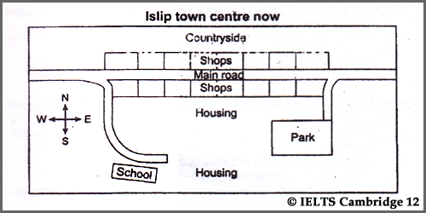

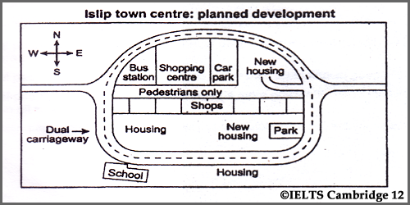

Summarize the information by selecting and reporting the main features, and make comparisons where relevant.

Write at least 150 words.

Sample Answer

序論
The depicted maps of the center of the small town known as lslip provide information about the current city and what it will look like in future. Overall, a good number of adjustments can be detected in the plan and the town will look like a completely different one when the changes are made.

本論
At the outset, as it is observed in the current town map, the center is in close proximity to the countryside, which is to the north. The main road on east-west direction divides the town, and on both sides, there are 16 shops. The south side is a residential area where the road on the right-hand leads to a park while the road on the left, leading to the housing area, curves a little in front of a school.

As far as the planned development is concerned, the town will have a completely new outlook. The main road will be transformed into a dual carriageway and surround the whole town creating a circle. Moreover, a bus station, shopping center, car park and new housing areas will be built on the north side. However, the shops, school and park will remain as they are. The north and south part will be divided by a pavement for pedestrians.

結論
In summary, the small town of Islip will be more organized and the outlook will be praiseworthy when the plan is applied.

＜220 words＞ Band 8.0 score

【語彙】
depicted (形) 描写されている、示されている
Overall, (接副) 概して、全体としては、全般的に見れば◆文頭で用いて
a good number ofかなりの数の
adjustment (名) 変更、調整、修正
《be ～》detected ～が検出される［認められる］
At the outset, (副) 最初に［は］
in close proximity to ～のすぐそばに
a residential area 住宅街
as far as ～ is concerned ～となると、に関する限り、に関するかぎり、に取って
dual carriageway中央分離帯のある（幹線）道路
pavement (名) 歩道、人道
pedestrian (名) 歩行者
In summary, 要約すれば、手短に言えば

- ～に位置している
★主にSite Planで使う
be located / be situated / lie

★Floor planで使う
be positioned / be placed / be suited

- 状況を示す
be surrounded by ～ = ～に囲まれている

- 移転する
be moved to ～ / be relocated to ～

- ～の反対側に
on the opposite side of ～
across from ～

- ～の隣に
close to / next to / right next to / adjacent to ～

- ～沿いに
along / alongside

〇〇〇 has changed to ●●●
modified
alternated
advanced
innovated
replaced into
replace A with B 【AをBに置き換える［置換する］】

